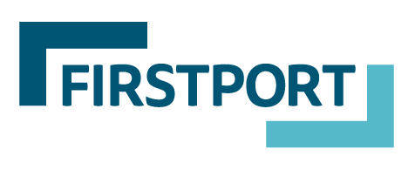

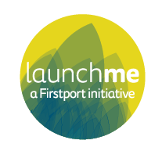

LaunchMe Round Six
Guidance Notes

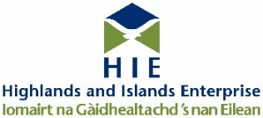
Guidance for applicants

Thank you for your interest in applying to LaunchMe. We are looking forward to supporting the next group of ambitious social enterprises that are ready to scale and increase their social impact.

If you think you have what it takes and are ready to commit to an intensive programme of support, we are keen to help so you have the best chance to make it onto the programme. These guidelines have been developed to support your application, so you should read them thoroughly prior to completing your application form.

If you’re interested in applying, join us at one of our upcoming roadshows for more information:
- Webinar – Thursday 12th November, 1pm
- Webinar – Thursday 19th November, 12noon
- Webinar – Tuesday 24th November, 11am

If you’re unable to attend one of the above dates, email us on launchme@firstport.org.uk and we will let you know about other opportunities to chat to our staff. Please also keep an eye on social media for more information.
Table of contents

What is LaunchMe? | 1
What are the benefits of LaunchMe for my social enterprise? | 1
When does LaunchMe take place? | 3
ChooseMe: LaunchPad | 3
ConnectMe: the journey to investment | 4
Who can apply for LaunchMe? | 5
What is social investment? | 6
What is social investment tax relief? | 7
A note on State Aid | 7
Completing the application form | 8
The application process | 9
I don’t think my social enterprise is ready for LaunchMe | 9

How to contact us
Get in touch if you have any questions about LaunchMe or need help to complete your form.
launchme@firstport.org.uk , 0131 564 0331 Firstport, 5-7 Montgomery Street Lane, Edinburgh EH7 5JT

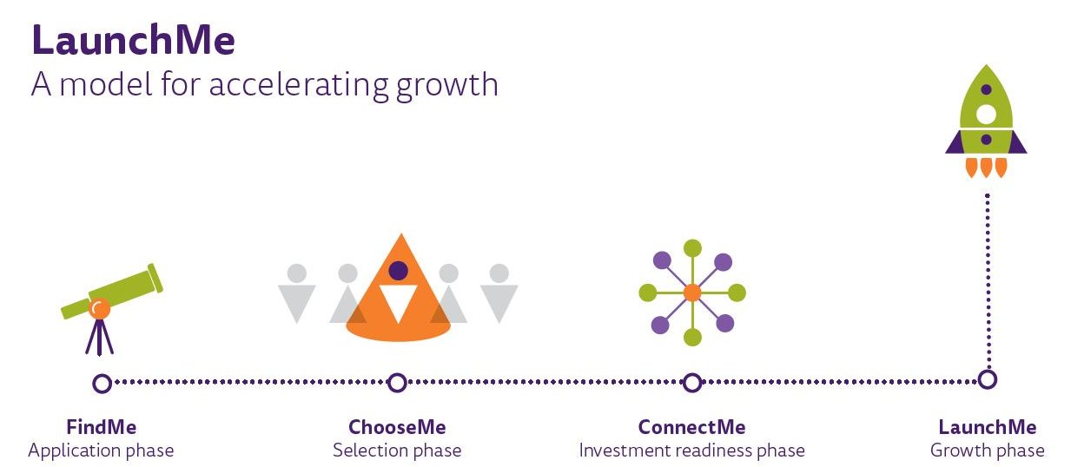
What is LaunchMe?

LaunchMe is Scotland’s social enterprise accelerator. It supports ambitious, social enterprise start-ups to scale and increase their social impact. The programme provides seed funding, intensive business and investment readiness support, professional expertise, investor matchmaking, a peer support network and access to grant funding as co-investment to any private investment secured through the programme.

LaunchMe aims to develop a pool of strong, capable and ambitious social enterprises that can go on to secure investment so they can achieve social impact at scale. Since 2014, it has supported 29 participants to secure over £1m of investment from both private investors and social financing institutions. The fifth round is currently underway, and the selected enterprises will be pitching for investment in the Autumn.

LaunchMe has raised the aspirations, confidence, and capacity for growth in social enterprise start-ups. Participants in previous rounds have reported that they would not have implemented plans for growth or would have taken longer to achieve them if it had not been for the programme. To find out more about the LaunchMe model and its impact over the past five years, read our publication.

The sixth round of LaunchMe is looking to support up to eight social enterprises with the commitment and ambition to grow and achieve greater social impact. It is open for applications until noon on Monday 14 December 2020. Read this guidance in full and if you think you are ready to take your social enterprise to the next level, complete your application form before the deadline.

What do you get?
As a LaunchMe participant, you will be part of a group of ambitious social enterprises pioneering new ways of financing social impact in Scotland. You will receive:

Professional Expertise, Training & Advice

We have built a network of industry experts to help you strengthen every area of your business and get you ready to scale - social impact, IP, finance, risk management, digital and more. This is not your bog-standard training. Every expert session is tailored to the needs of the cohort, so you are getting access to exclusive content and advice that meets your needs.

Business Support

Our advisors will work with you on a one-to-one and group basis to put a scale up plan in place. Our advisors are experts in their field and understand the unique drivers for social entrepreneurs, plus they have helped many others like you to achieve their growth plans.

Peer Support

You will be working with other social enterprises on a similar journey. You will become each other’s sounding board and a safe space to share experiences, ideas, and concerns.

Access to Networks & Investment Opportunities

We know that achieving the right funding mix for your scale up plan may require different types of finance - angel investment, institutional investment and sometimes grant funding too. We have supported dozens of social enterprises to scale before, so we have access to lenders and investor networks who can help you achieve your growth plan.

Seed Funding

As part of the LaunchMe programme, you will receive £10,000 as a repayable grant* which you can use towards getting investment ready.
*A repayable grant is awarded as a grant in one lump sum and repayments start after year one and once the enterprise starts making a surplus.

When does LaunchMe take place
Round Six of LaunchMe takes place between October 2020 and November 2022. See the journey below for what is involved at each of the four phases.
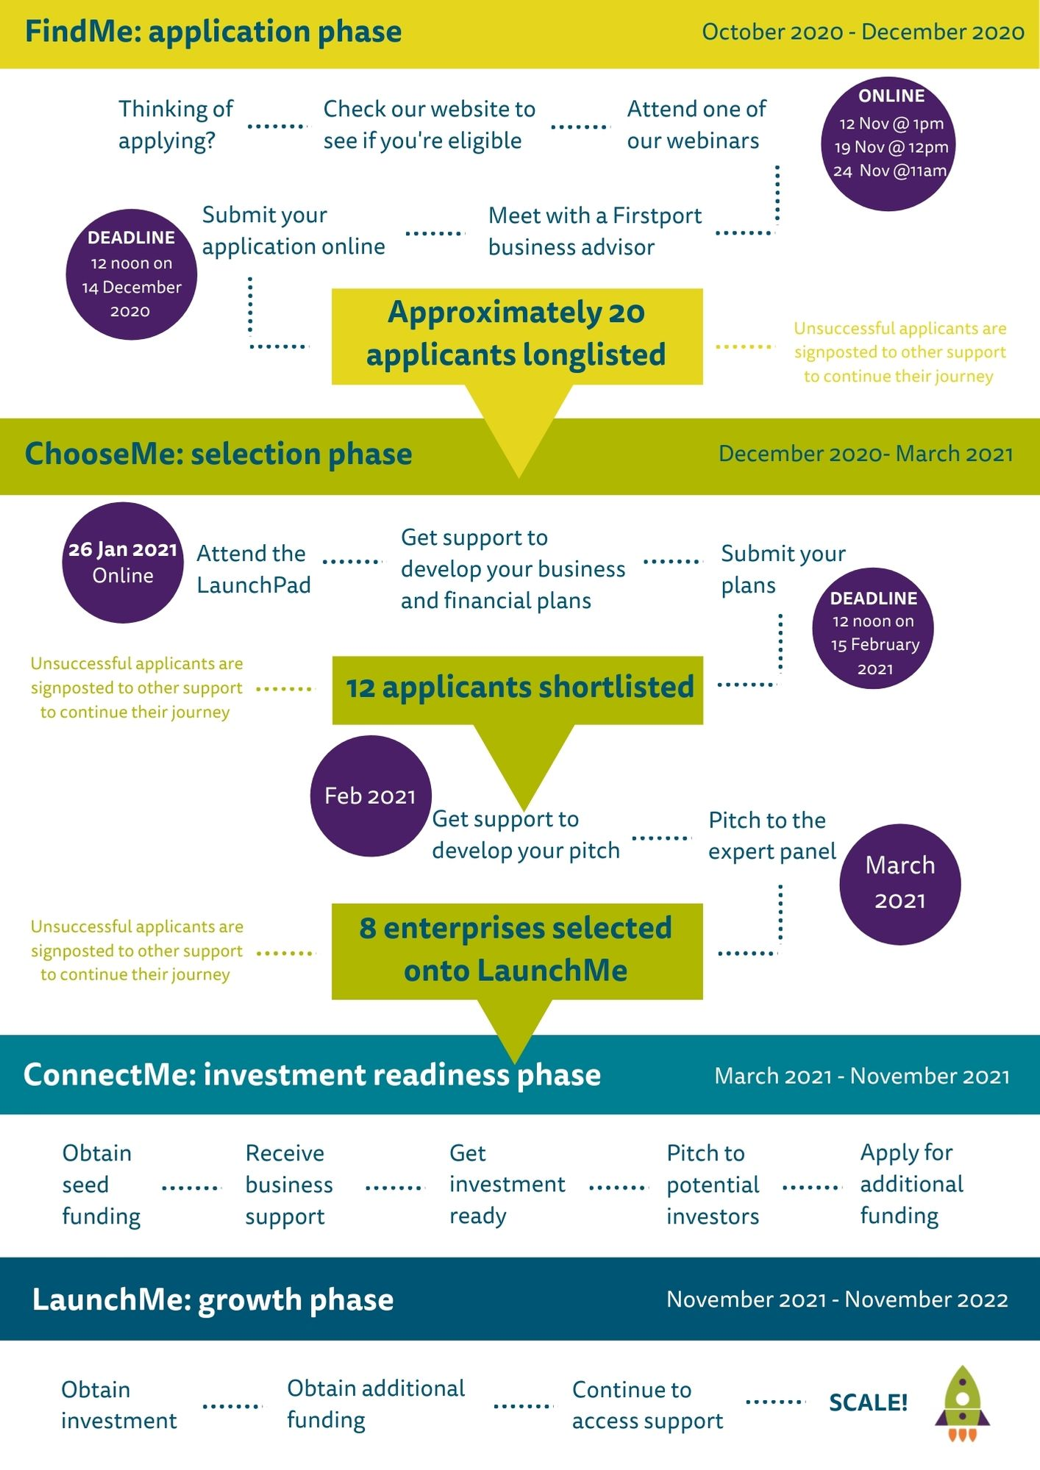

ChooseMe: LaunchPad

Following the online application process, you will be notified within five weeks as to whether your application has been longlisted. Individuals who are longlisted will be required to attend the LaunchPad event which is likely to be online on 26 January 2020.

The LaunchPad is an all-day event designed to help applicants gain more information on the programme and help them to prepare for the next phase of the selection process.

It will provide you with an initial steer on the key features of a strong business plan, focussing on growth to secure investment. The event also provides the opportunity to network with other ambitious social entrepreneurs, find out more about what social investors are looking for and hear about the additional support and expertise available from our programme partners.

This is a mandatory part of the selection process, so please ensure you are available to attend before submitting your application.

Following the LaunchPad, longlisted candidates will receive individual business guidance to develop their business and financial plans. They will then submit revised plans by noon on the 15th of February.

After the business plan submissions there will be a further shortlisting and 12 candidates will go through to the pitch stage. If you are successful in reaching this stage, you will receive pitch development support to ensure you are prepared for the expert panel event that will take place in March 2021. Up to eight social enterprises will be selected for the LaunchMe programme and proceed onto the ConnectMe phase.

ConnectMe: the journey to investment
The main purpose of LaunchMe is to give social enterprise start-ups the support they need to become investment ready, and then to be able to secure an investment deal. The image below explains the journey to investment which takes place during the ConnectMe phase of the programme.

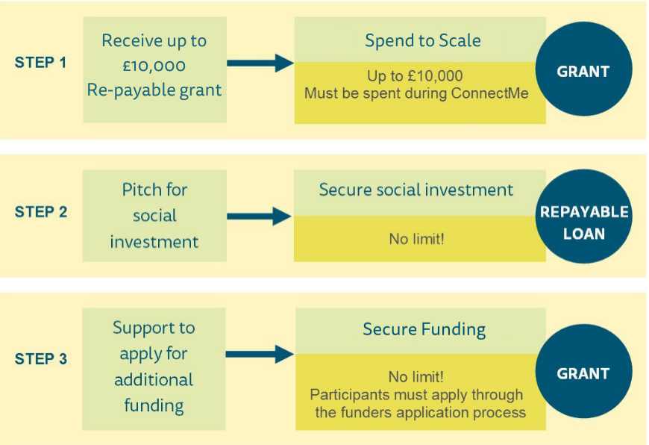

Step 1 - Seed funding
In your initial application, you can request up to £10,000 in repayable grant funding from LaunchMe to help your social enterprise become ‘investment ready’. This is called seed funding. Under the heading ‘Growth Plan’ in the application form, you should tell us how much seed funding you need and what you will spend this on.

This funding must be spent during the ConnectMe phase (from March to November 2021), so please think carefully about what you need and how you will use it.

You should spend seed funding on getting ready to scale up – employing more staff, finding new premises, or purchasing more equipment. You may need specialist legal advice, or to develop your branding and marketing. These are just examples – if you are shortlisted for the programme, you will be given support to develop a detailed plan and budget for using your seed funding. Please note that seed funding cannot be used to pay off old debt.

Step 2 - Investment
If you are selected to join the LaunchMe programme, we will work with you to develop your business model and to strengthen your value proposition – what you are ‘pitching’ to investors. We will help you to meet and negotiate with potential investors to secure an investment deal.

Step 3 - Additional funding
We will also provide support to access a pool of grant funders who may act as co-investors to any private investment secured through the programme.

Please be aware that participants will be required to apply to grant funders through their usual application process – the additional grant funding is therefore not guaranteed and will be very competitive. However, your participation on the LaunchMe programme will strengthen your application and provide connections to a network of relevant funders.

We will also provide guidance on other means of securing funding. For example, crowdfunding, loan stock and community share offering.

Click here to read interviews of previous participants and find out more about the journey securing investment and funding.

Who can apply for LaunchMe?
LaunchMe isn’t right for everyone, we’re looking for the next generation of social enterprise visionaries. We want to help social enterprises that are innovative, focussed on scaling their impact and prepared to take risks and work hard.

While we welcome applications from all sectors, we are particularly interested in social enterprises developing digital or data for good solutions to social issues.

The fifth round of LaunchMe will support a group of up to eight social enterprises to prepare for growth and secure investment. Broadly speaking we are looking for applications from two main groups:

- Social enterprises
Either start-ups with a scalable idea and big plans for growth; or established social enterprises (up to £200K trading income) looking to develop a new product/service to diversify and grow
- Community groups
Newly formed or well-established community groups or community enterprises looking to develop a product or an asset with the potential to generate significant income and have a positive impact in the local area.

Before you apply, please check you are eligible using the checklist below. If you’re not sure whether you meet these criteria, please get in touch before you submit your application. Ineligible applications will not be considered for the programme.

To be eligible for LaunchMe, you must be:
- One of the types of organisation described above;
- Operating primarily for the benefit of people or communities within Scotland;
- Able to demonstrate a track record of delivering social impact or a strong potential to deliver social impact.
- Based in Scotland
- Ambitious, with clear, well considered growth plans but have not yet secured appropriate investment to fund your plans;
- Able to commit to participating in a programme of intensive business and investment support between March and November 2021;

LaunchMe cannot support:
- Party political activities or activities which promote a particular religion.
- Any services or activities that statutory bodies have an obligation to provide.

What is social investment?
Social investment refers to repayable finance that is intended to stimulate both financial and social returns. There are many different types of social investment. The simplest and probably most common model is when an investor gives a loan to a social enterprise. The social enterprise then uses it to generate social impact (for example, buying a new building to increase access for the people they want to help) and increase their turnover (for example, by having space for more customers). Unlike a grant funder, a social investor expects to be paid back some or all of their investment, often with interest.

Social investment has been around for a while but for many organisations in Scotland, it might be new and this may be the first time they consider it. It is not without risks; you are after all taking on debt. However, it can provide growth opportunities for successful social enterprises, while building new relationships with investors who want to support the benefits that you deliver.

If you lead a social enterprise, are trading, and are thinking about growth, then social investment could help you. For example:

- You might need a capital injection to make a large purchase, for example, a building.
- You might need access to working capital or an overdraft facility to stabilise your cash flow through periods where lower sales are forecast.
- You might be looking for a bridging loan to help you take on new staff before they start to generate an increase in turnover.
- You know that there is potential to increase your customer base, but you need to invest in new equipment in order to deliver services on a bigger scale. You need some capital to get you going.

Social investors come in all shapes and sizes, and to date, LaunchMe participants have secured investment from a variety of sources, including:

à Individual investors. Most of the LaunchMe participants have secured their investment from individual investors. In many cases, we have helped participants to connect with suitable investors, although some participants found investors through their own networks and contacts. In most instances, when you work with an individual investor, you can negotiate competitive interest rates and repayment plans. You can also get the added value of accessing your investor’s knowledge, expertise and contacts. Read our case study on Paul who secured investment this way.

à Social investment providers. These may be Community Development Finance Institutions (CDFI) or ethical banks that offer specific products for charities and social enterprises. Some LaunchMe participants have secured part of their investment this way, primarily from Social Investment Scotland. Read our case study on Lesley who secured a loan from Social Investment Scotland, alongside private investment.

à Your own community. You may decide to raise some of your investment through crowdfunding or a loan stock option, by attracting individuals and organisations who share a common interest with you and what you are trying to achieve. Individuals who invest in you through a loan stock option do not ‘own’ any of your business. This is a debt investment so they would be lending you money which you would be due to pay back with interest. Read our case study on Reuben who secured investment this way.

Which source of investment is best for you will depend on your growth plan and it may involve a combination of any of the above. We will help you throughout your involvement in the programme to understand and access the best option for you.

What is social investment tax relief?
Social investment tax relief (SITR) helps social enterprises raise finance by offering tax relief to individual investors.

SITR is designed to help you raise money to support the trading activity of your social enterprise or charity. It does this by offering your investors tax relief on their investment if the qualifying conditions are met.

Whilst compliance with SITR is not a requirement to participate on LaunchMe, it is an attractive proposition for potential investors and as such we would encourage applicants to look at the SITR rules.

Read the full details on SITR from the HMRC here. If you have any questions, please email us on launchme@firstport.org.uk.

A note on State Aid
State Aid is a specific legal term arising from the European Union treaty which constitutes financial aid to organisations carrying out economic activity (whether or not for profit) which could distort competition. We need applicants to consider whether their project meets State Aid requirements.

If LaunchMe funding could give you an advantage over other organisations offering similar goods or services, or if the activities you want us to fund could affect trade between EU member states, then our funding might be considered to be ‘State Aid’. You can find out more about State Aid here.

State aid rules are complex, but as a very general guide projects involving trading activities are unlikely to breach state aid rules if they are small scale; delivered in a defined local area; are for charitable, social, cultural or educational purposes; and do not affect trade between member states of the European Union.

It is your responsibility to understand your State Aid position when submitting an application to us for funding and when signing any subsequent contract.

If you’re not sure whether you meet these criteria, please get in touch before you submit your application.

Completing the application form
Applications must be made online by completing the application form found here.

If you need an application form or this document in another format, please contact us on 0131 564 0331 or email launchme@firstport.org.uk.

The form is designed to give us a brief overview of your social enterprise, so you shouldn’t need to write more than the word limits.

You will be able to navigate through the application form, without completing the required fields, to see the questions and prepare. When you submit your application, it will take you back to any required fields that you have forgotten to complete.

The online form allows you to save and resume if you don’t complete the form in one go. The form uses your browsers storage to save your progress. This means that when you press save, you can navigate away from the form, and when you next work on your answers it will have your previous answers filled in already.
Important things to note:
- Your form is saved on the browser you are using when you press the save button. This means that you will only be able to view your saved progress when using the same device and browser as before.
- This save function is dependent on your browser history, if you delete your history, and/or browser caches you will risk losing the progress on your application.
- This save function is best used for saving progress as you fill the form in. We highly recommend drafting your answers on the available application Word document before submitting your application to ensure your answers are not lost at any stage.

You must submit your completed application form by 12 noon on Monday 14th December 2020.

As part of the application, you will be asked to upload a copy of your most recent annual accounts. If your enterprise has been trading for less than one year or your annual accounts are not yet ready, you will need to submit your most up to date cash flow (including every month of trading since you started). In this instance, you will also be required to submit evidence of your financial performance at a later stage of the application process.

If you have any queries or would like support to strengthen your application, we would encourage you to engage with our team at one of our webinar events (see page 1 for details and dates) or at a one to one meeting at any point before the deadline date.

The application process
You can submit your application at any time before the deadline but it will not be assessed until after the deadline date. After submitting your application online, you will receive an automated reply acknowledging receipt of your submission.

You will be advised of the outcome of your application within 5 weeks of the deadline date. Ineligible applications will be notified by letter. Longlisted applicants will be contacted by email and will be required to attend the LaunchPad on 26 January 2020. See page 2 for further details on the LaunchMe journey.

I don’t think my social enterprise is ready to apply for LaunchMe
Firstport provides free training on all aspects of setting up and running a business through the Just Enterprise programme. Find out more and book a place.

Firstport also offers funding to support start-up social enterprise. You can apply for up to £5,000 to get your idea off the ground, or up to £25,000 if your business is able to show evidence of a track record in generating income and social impact. You may also be eligible for our repayable grant: Boost It. Boost It offers up to £50,000 in repayable grants to help social enterprises in need of a large capital injection to get their ideas up and running, or to sustain trading. Find out more.

