How to log in to Fine Tune:
Click the link in your email confirmation, which will open the event preview page (don’t worry once the event starts this will be updated with the live events running!) Click on ‘Set up login’
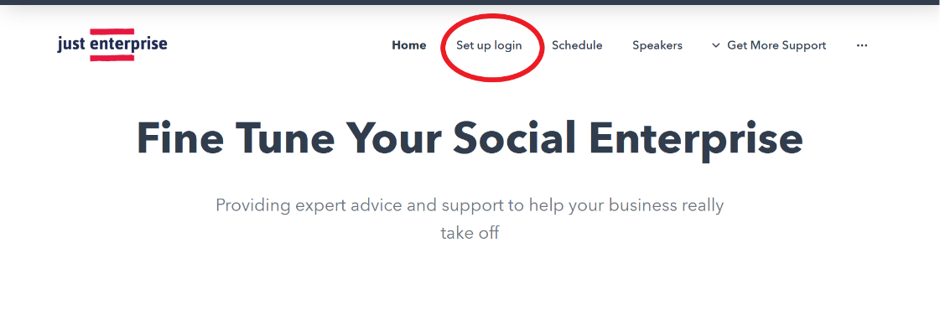
Then select ‘+ Add to Cart’ and click next.
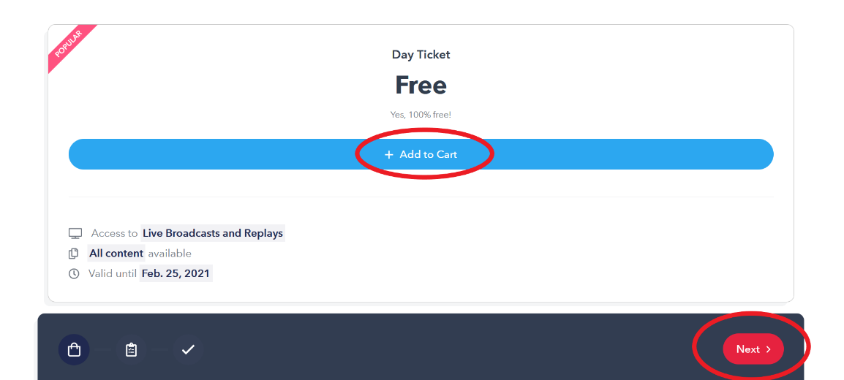
Next, you can choose the talks you want to attend, we highly recommend attending all of the talks to get the most out of the day. You can select this easily by clicking the select all button on the right hand side, as below.
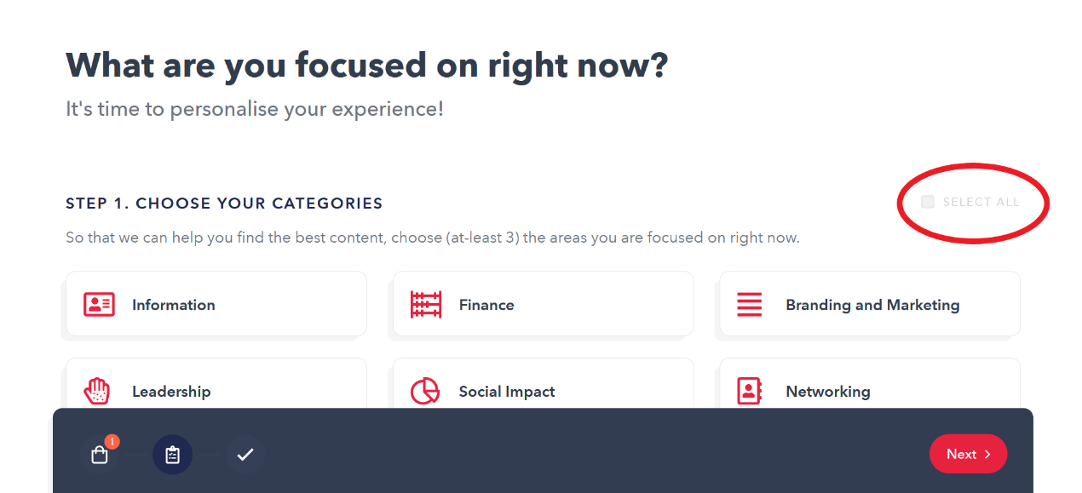

This has selected all themes, next click select all to book into the full day schedule, and click ‘next’.
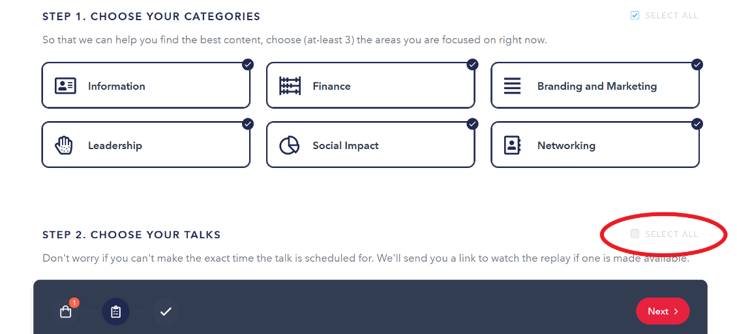
Finally enter your email address and full name, and click Save Details. You will receive a confirmation email (from HeySummit) and another email shortly afterwards with your schedule details.
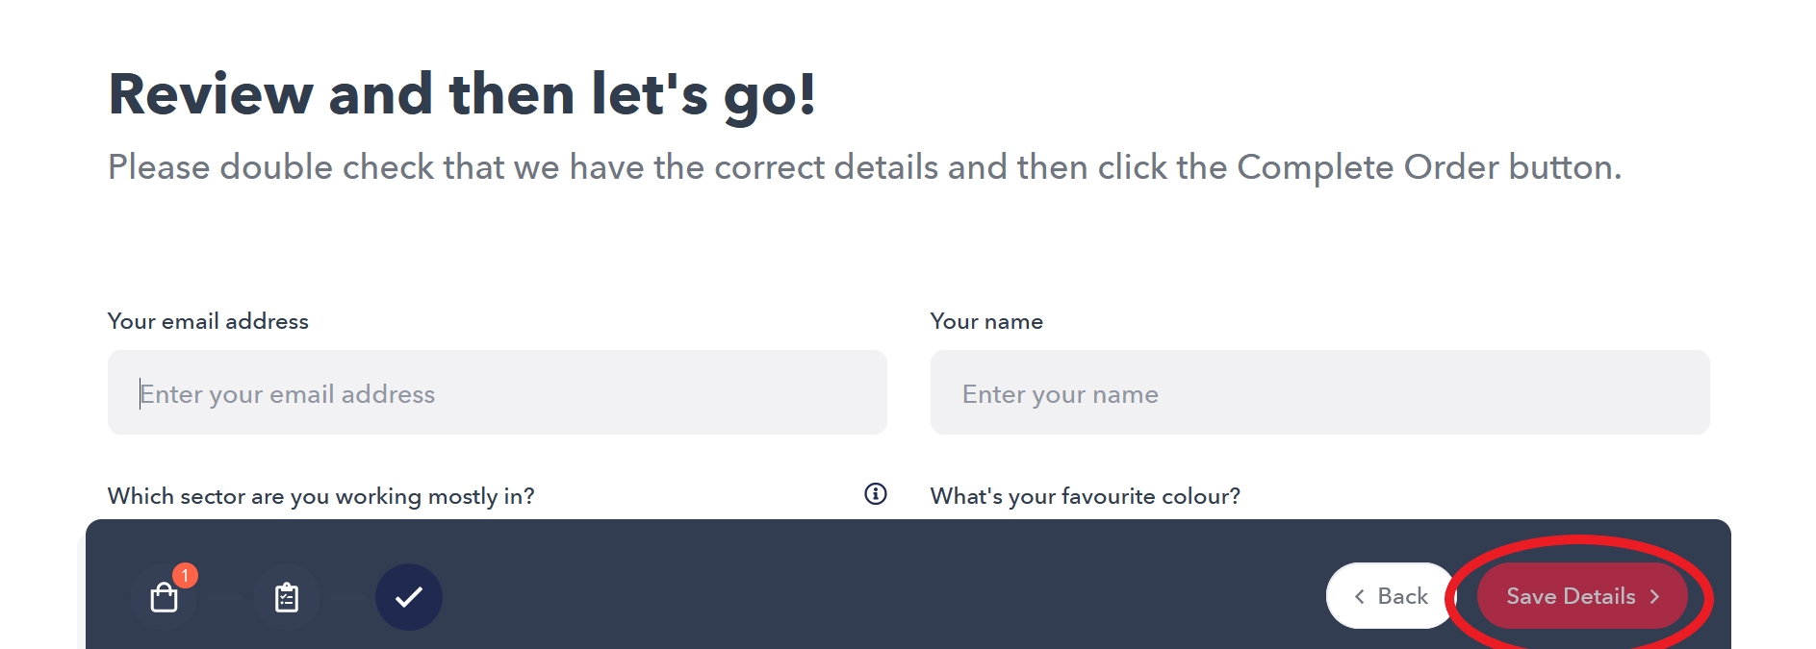

On the day of the event, simply follow the link in any of your emails and log in to start your first session.
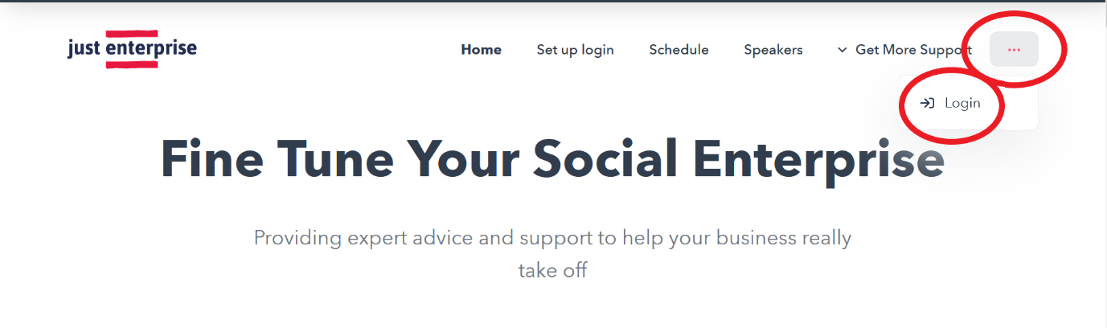Enter your email and press continue, this will send you a login email which will look like this: 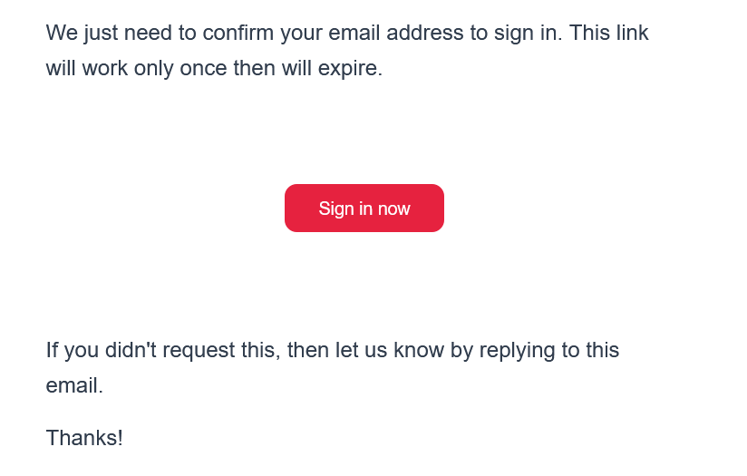
All you’ll need to do is create a password to access the event on the day, please make sure you save this password in a save place, as we will not be able to retrieve it on your behalf.

