Catalyst Fund Guidance Document:

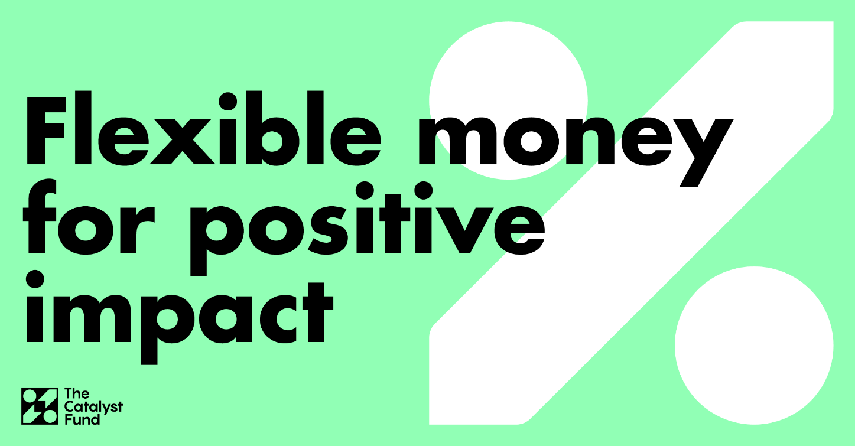
Introduction:
The Catalyst Fund offers loans starting at £50,000 and is designed to support ambitious social enterprises to start and scale their business through social investment by offering a patient, revenue-based repayment model
What is it?
A new type of social investment offering loans through a patient, flexible repayment model, that gives you time to grow.
Who is it for?
For social enterprises in Scotland with potential to deliver significant social impact but unable to access existing social investment products. For example, start-ups with significant set up costs or scale ups that need more time to generate income before paying back their loans.
How it works?
The Catalyst Fund offers a flexible repayment model, this means that social enterprises make repayments as a proportion of their sales income; on good trading months you will pay back more, on months where trading revenue is lower, you will pay back less.
A model like this gives your social enterprise the time and flexibility it needs to grow at a pace that matches your ambitions.

Why this model?
Because for some social enterprises, accessing traditional social investment can be difficult; social investment loans usually require fixed repayments to start whilst enterprises are still building an income. For those enterprises that face the high costs associated with technology development, research and design, and building capacity, beginning to repay loans straight away is not a viable option.

Where can I find more information?
For more details you can read through this document and go to the Firstport website to find out more and book a place at an information webinar.
To be eligible you must meet the following criteria:

- I am 16 or over
- I am a permanent resident in Scotland
- My enterprise/idea is operating primarily for the benefit of people, or communities within Scotland
- The activities of my enterprise do not involve political campaigning or the advancement of religion
- Have you received funding from Firstport before? If yes, then you must be able to confirm that you have completed the required sign-off process
- My enterprise aims to provide direct social benefit to individuals, communities and/or the environment. Firstport does not fund enterprises whose main activities are directed at providing benefit to other organisations
- My enterprise is up and running and I am able to provide evidence of potential income generation and social impact.
- Profits from the enterprise are reinvested in the business and its social aims. No assets or uncapped dividends may be transferred out of the organisation to private individuals or bodies. Note: you (and any other individuals working for the enterprise) will still be able to take a fixed salary, but profits generated on top of this must be reinvested
- I am able to demonstrate a track record / potential of delivering environmental social impact
- Have you considered other forms or providers of investment to fund this project/ your business? (eg banks, other social investors, angel investment)
If yes, you must be able to provide details of what you have considered/applied for. If you were not able to access or secure other funding, you must share the reasons given.

How does the fund work?
The Catalyst fund is designed to support social entrepreneurs who require significant investment to grow but whose revenue streams may take time to develop or become reliable.
How to apply:
    - Attend our information webinars.
We will be running a series of information webinars over the summer, these are designed to outline the core eligibility of the fund, the application and assessment process, as well as answer any questions you may have about our flexible finance model.
    - Submit an expression of interest.
If you are interested in applying for the Catalyst Fund, the first step is to submit an expression of interest. The expression of interest will involve answering a couple of simple questions to give us an idea of what your social enterprise does, and why you think this type of funding is suitable for you. After submitting this, a member of staff will be in touch within three days to invite you to have an informal meeting about your social enterprise. This meeting is designed to help you decide whether this type of finance is suitable for your organisation at its current stage. If it’s right for you then we will send you a link to our online application form for you to complete.
    - Online application form:
This is a straightforward application form designed to help applicants articulate their investment requirement, business growth plans and potential risks. It will also collect applicants’ primary details and references. This form does not have a save function, so we would advise all applicants to use our Word application drafting document prior to filling out the application. If you are having trouble with the online form, please let us know. Below outlines some of the accompanying documents you will need to submit your application form.

Business plan (optional)
If submitted, your business plan must be submitted as a PDF document only. The business plan should clearly state the vision and background of the enterprise, its products and/or services, its income generation and social impact to date, and include both market and competitor analyses.
Cash flow projections
Your cash flow projections should show us how you see the business progressing over the next 3 years, in terms of the income streams you intend to develop and the expenses you expect to incur. This must be submitted in our Excel cash flow template (attached).
We understand that many applicants have already developed their own cash flows, but we need to ensure the projections are up to date and comparable with other applications. You may change some of the headings in the template to suit your enterprise, but no other template will be accepted. For further advice on completing your cash flow projections, see Cash Flow (Additional Guidance).

Most recent annual accounts (if available)
Annual accounts should be submitted as a PDF document only. They do not need to be audited and are not a mandatory requirement for the application if they are not available.
Most recent year-to-date management accounts
This should include all income and expenditure incurred to the most recent month end date in your financial year. This can be in a spreadsheet or download from accounting software.

Additional Guidance:
Cash Flow (Additional Guidance)
At assessment stage, the cash flow will be reviewed with the following in mind:
Can the business service the repayments?
Your projections should show that your enterprise has the potential to develop into a financially viable and sustainable business. Successful applications will be able to demonstrate that the Catalyst investment will result in increased trading, which will then allow the enterprise to comfortably service the repayments, as a percentage of revenue.
Has the applicant used the key assumptions effectively?
The assumptions under the main cash flow should be used to clarify anything that may be questioned by a reader. If in doubt, err on the side of caution and provide an explanation or further break down of the figures. Never assume the reader will work it out or come to the same conclusion as you. We should be able to understand the business.
Are there clear links between income and expenditure?
For example, increased product sales usually means increased manufacturing expenditure. If the enterprise takes on additional staff (and therefore additional salary expenditure), what is the effect on projected income? The more you know about your income and expenditure, the more accurate you can be.
Are the projected figures realistic?
Sales figures rising by a significant percentage without good supporting evidence in the key assumptions can be seen as unrealistic. Similarly, you should show an awareness of how income and expenditure might vary over the three-year period, and how this might affect the enterprise’s overall finances. For instance, if you expect your enterprise to be busier at certain times of the year, can you show a corresponding increase in expenses (such as staff time)? And are you able to cover overheads during quieter periods? A common mistake in applications is “flatlining” – income and expenditure remaining static month after month. While there may be some items that are unlikely to fluctuate – e.g. rent, some direct debits – other costs and income streams will inevitably vary depending on the month.
Is there an opening balance?
Your opening balance should not be left blank or show a zero balance. Use this to show the enterprise’s current balance and the key assumptions to reflect how this amount has been generated to date. If your enterprise has a negative bank balance, you should show this and use the assumptions to provide an explanation.
Is the Catalyst Fund loan included in the cash flow projection?
This is a common mistake. Your cash flow should show the Catalyst Fund Loan (as one lump sum) as income in the first year – when repayments start from Year 2 onwards, they will automatically calculate.

FAQs:
How often are there information webinars?
We will be running regular webinars to provide you with more information about the Catalyst Fund. You can find a full list of webinar dates and times on our website.
How does this compare to a private loan, or traditional social investment?
Traditional social investment mostly takes the form of term loans with fixed repayments each month with an interest rate applied. Loans from private investors typically utilise the Social Investment Tax Relief, which means there are no repayments for the first three years, after which you make arrangements with the investor on how repayments will be made. Catalyst has variable repayments from year 2 and is repaid for as long as it takes to reach a pre-agreed multiple of the investment. The total amount you will repay with Catalyst will be similar to a term loan but the variable repayments ensure that it will be affordable as your business grows.
I am a start-up social enterprise, is this fund for me?
Whilst we accept early stage enterprises, you should be able to evidence trading income. This should be more than market research and should at least include trial trading, or letters of intent from interested customers, or pilots.
I just want to access the application form, can I do so?
Due to the nature of loan funding, it is necessary to have a chat with one of our staff members before submitting an application form. This will help to establish whether this fund is right for you and allow you to chat to one of our advisors before submitting a formal application.
Once I have applied, how long will it be until I receive a decision?
After you have submitted an application, you will receive a decision within 8 weeks.
I have already secured social investment, am I still eligible for this fund?
If you require further investment to grow AND will be able to service additional repayments, but cannot access this from other social investment providers, then you may be eligible. You should attend a webinar to learn more and, if appropriate, submit a note of interest.
What is revenue-based investment?
Revenue-based investment, revenue-based finance, revenue participation and quasi-equity are all terms used to describe similar funding practices where repayments are based on the performance of the organisation. A Catalyst Fund loan will be repaid by a percentage of your revenue until you repay an agreed multiple of the original investment amount. The overall total you repay will be like other social investment products that charge interest, just calculated differently.
Will the Catalyst Fund accept early repayment?
Yes. Your repayment will naturally increase with good trading performance but you may decide you want to pay off more earlier, or you may accept follow-on investment from another investor which enables you to exit from Catalyst. We are happy to discuss this.

