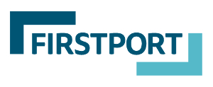

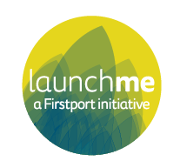

LaunchMe Round Seven
Guidance Document
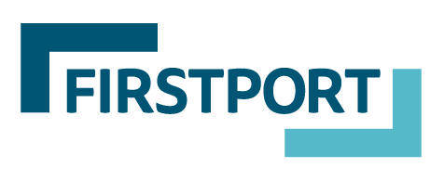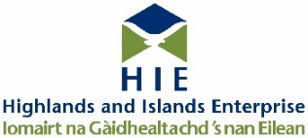

Guidance for applicants

Thank you for your interest in applying to LaunchMe. We are looking forward to supporting the next group of ambitious social enterprises that are ready to scale and increase their social impact.

If you think you have what it takes and are ready to commit to an intensive programme of support, we are keen to help so that you have the best chance to make it onto the programme. These guidelines have been developed to support your application, so you should read them thoroughly prior to completing your online application form.

If you’re interested in applying, join us at one of our upcoming webinars for more information:
- Wednesday 27th October at 1pm
- Thursday 11th November at 6pm
- Tuesday 23rd November at 12.30pm
- Wednesday 8th December at 8am
- Monday 10th January at 10am

Deadline for applying: Noon 17th January 2022

If you’re unable to attend one of the above dates, email us on launchme@firstport.org.uk and we will let you know about other opportunities to chat to our staff. Please also keep an eye on social media for more information about our upcoming webinars and previous LaunchMe participants.
Table of contents
What is LaunchMe? | 1
What do you get? | 1
When does LaunchMe take place? | 3
ChooseMe: LaunchPad | 3
ConnectMe: the journey to investment | 4
Who is LaunchMe for? | 5
What is social investment? | 6
What is social investment tax relief? | 7
A note on State Aid | 7
Completing the application form | 8
The application process | 9
I don’t think my social enterprise is ready for LaunchMe | 10

How to contact us
Get in touch if you have any questions about LaunchMe or need help to complete your form by filling out our contact form, emailing launchme@firstport.org.uk , or phone 0131 564 0331
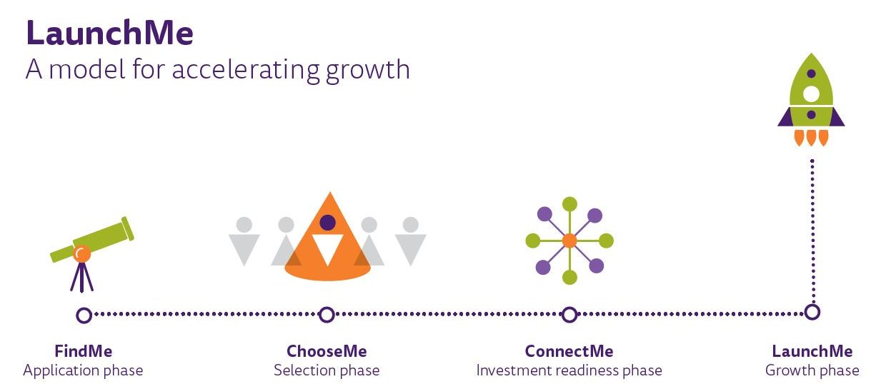
What is LaunchMe?

LaunchMe is Scotland’s social enterprise accelerator. It prepares ambitious social enterprises and community organisations for growth so that they can achieve social impact at scale. The programme provides repayable seed funding, intensive group and 1:1 business and investment readiness support, professional expertise, connections to investment opportunities and a peer support network.

Since 2014, LaunchMe has supported 44 participants to secure over £1.35m of investment from both private investors and social financing institutions. We are currently accepting applications for the seventh round, and up to eight enterprises will be seeking investment during the ConnectMe phase, April – November 2022.

LaunchMe has raised the aspirations, confidence, and capacity for growth in social enterprises and community organisations throughout Scotland. Participants in previous rounds have reported that they would not have implemented plans for growth or would have taken longer to achieve them if it had not been for the programme.

Some quotes from past participants:

“The LaunchMe programme validated our business proposals which has had a big impact on our community, increasing their awareness and raising their aspirations”

“Some of the learning content was challenging, however it all came together over the programme leading to informed decisions”

“I have been inspired by other businesses leaders on the LaunchMe cohort”

“The LaunchMe process has brought together a wide range of learnings and thinking to develop, reorganise and build the organisation. It has helped to inform big decisions and led to changes within the organisation”.

Firstport are at the forefront of social investment connections for early-stage social enterprises and community organisations. The launch of new products for social enterprises such as The Catalyst Fund combined with experience of private investment and other social investment connections means that we are very well placed to support your search for investment.

To find out more about the LaunchMe model and its impact over the past five years, watch our latest video and case studies on the Firstport Website

The seventh round of LaunchMe is looking to support up to eight social enterprises and community organisations with the commitment and ambition to grow and achieve greater social impact. It is open for applications until noon on Monday 17 January 2022. Read this guidance in full and if you think you are ready to take your social enterprise or community organisation to the next level, complete your application form before the deadline.

Programme aims
LaunchMe aims to:
- Stimulate the ambition of social enterprises and community organisations so they can generate impact at scale.
- Help social enterprises and community organisations get investment ready so they can secure the capital to achieve their ambitions.
- Connect social enterprises and community organisations with the relevant sources of investment and expertise to realise their plans.

Which organisations are LaunchMe prioritising?
LaunchMe isn’t right for everyone, we’re looking for the next generation of social enterprise and community visionaries. We want to help social enterprises and community organisations that are innovative, focussed on scaling their impact and prepared to take risks and work hard.

The seventh round of LaunchMe will support a group of up to eight social enterprises and community organisations to prepare for growth and secure investment. Our priorities focus on:

- Social enterprises

Yes, if you are:
- An early stage or established social enterprise with ambitions to grow – you want to expand your services, reach new markets, and generate more social impact in the next 9-12 months.
- In need of support to develop and formalise systems and processes for your business.
- In need of investment and support to reach those ambitions.
- New to social investment- this is likely to be the first time you have considered investment to grow.
- Able to demonstrate evidence of sales and social impact by the time the cohort is selected in March 2022. If you are unsure if you have enough evidence, contact the LaunchMe team to discuss your current situation before applying.
- Able to fully participate in the programme, attending regular online or in-person sessions between April and November 2022, applying learning and reporting back on progress.

Community organisations

Yes, if you are:
- Developing a community asset or a product with the potential to generate significant income and social impact in the local area.
- In need of investment and support to reach those ambitions.
- Well-connected within your community and with the buy-in of key stakeholder groups.
- Supported by an engaged board of trustees.
- Working towards timescales that align with the programme (April-November 2022). For example, if the growth plans are dependent on the transfer of a community asset, the change of ownership will be already in place when the programme of support starts (April 2022).
- Able to fully participate in the programme, attending regular online or in-person sessions between April and November 2022, applying learning and reporting back on progress.

Before you apply, please check you are eligible using the checklist below. If you’re not sure whether you meet these criteria, please get in touch before you submit your application. Ineligible applications will not be considered for the programme.

To be eligible for LaunchMe, you must be:
- Based in Scotland and operating primarily for the social benefit of people, or communities, in Scotland.
- The activities of the enterprise do not involve political campaigning or the advancement of religion.
- The enterprise aims to provide direct social benefit to individuals, communities and/or the environment.
- The enterprise is incorporated and has an asset lock (This means that profits from the enterprise are reinvested in the business and its social aims and cannot be transferred to private individuals or bodies). If not incorporated yet, you have identified the most suitable structure for the enterprise and expect to be incorporated by 14 February 2022. This is the date that you will submit your business plan and financial forecast.
- The enterprise is ambitious, with aspirations for growth and has plans to scale up but has not yet secured appropriate investment to fund the plans.
- The enterprise does not provide any services or activities that statutory bodies have an obligation to provide.

Before starting your application, please confirm the statements below (if applicable):

- If your enterprise has received funding from Firstport before (Pounds for Purpose, Start It, Build It, Boost It), the sign-off process from the previous award has been completed.
- If the growth plans depend on the development of an asset (e.g., a building), the acquisition of the asset will be completed by the time the programme of support starts in April 2022.
- As the lead applicant, you can commit to fully participating in the programme, attending relevant sessions, and applying new learning.
- As the lead applicant, you can confirm that you have been authorised to represent the enterprise on behalf of the parent organisation/board of trustees (if applicable) and can take decisions about the future direction of the enterprise.
What do you get?
As a LaunchMe participant, you will be part of a group of ambitious social enterprises pioneering new ways to finance your commercial and social impact. The programme is intensive, and as such, you are expected to commit around hours per month to attend group and one-to-one sessions. In between sessions, you will be applying and incorporating the new learning into your business and processes. Remember, this support is designed to help your business and will challenge you to prepare to scale up. Firstport want to prioritise those that will benefit most from the LaunchMe programme, and you will need to demonstrate this in the application form.

You will receive:

Professional Expertise, Training & Advice

We have built a network of industry experts to help you strengthen every area of your business and get you ready to scale. Our experts are specialists in social impact measurement, IP, finance, risk management, digital maturity, market intelligence, sales assumptions, communications strategy, and more. This is not your bog-standard training. Every expert session is tailored to the needs of the cohort, so you are getting access to exclusive content and advice that meets your needs.

Business Support

Our advisors will work with you on a one-to-one and group basis to put a scale up plan in place. Our advisors are experts in their field and understand the unique drivers for social entrepreneurs, plus they have helped many others like you to achieve their growth plans.

Peer Support

You will be working with other social enterprises on a similar journey. You will become each other’s sounding board and a safe space to share experiences, ideas, and concerns.

Access to Networks & Investment Opportunities

We know that achieving the right funding mix for your scale up plan may require different types of finance - angel investment, institutional investment and sometimes grant funding too. We have supported dozens of social enterprises to scale before, so we have access to lenders and investor networks who can help you achieve your growth plan.

Seed Funding

As part of the LaunchMe programme, you will receive £10,000 as a repayable grant* which you can use towards getting investment ready.

*A repayable grant is awarded as a grant in one lump sum and repayments start after year one and once the enterprise starts making a surplus.

When does LaunchMe take place?
Round Seven of LaunchMe launches in October 2021, with an application deadline of 17 January 2022 and business support phase from April – November 2022. See the journey below for what is involved at each of the four phases.
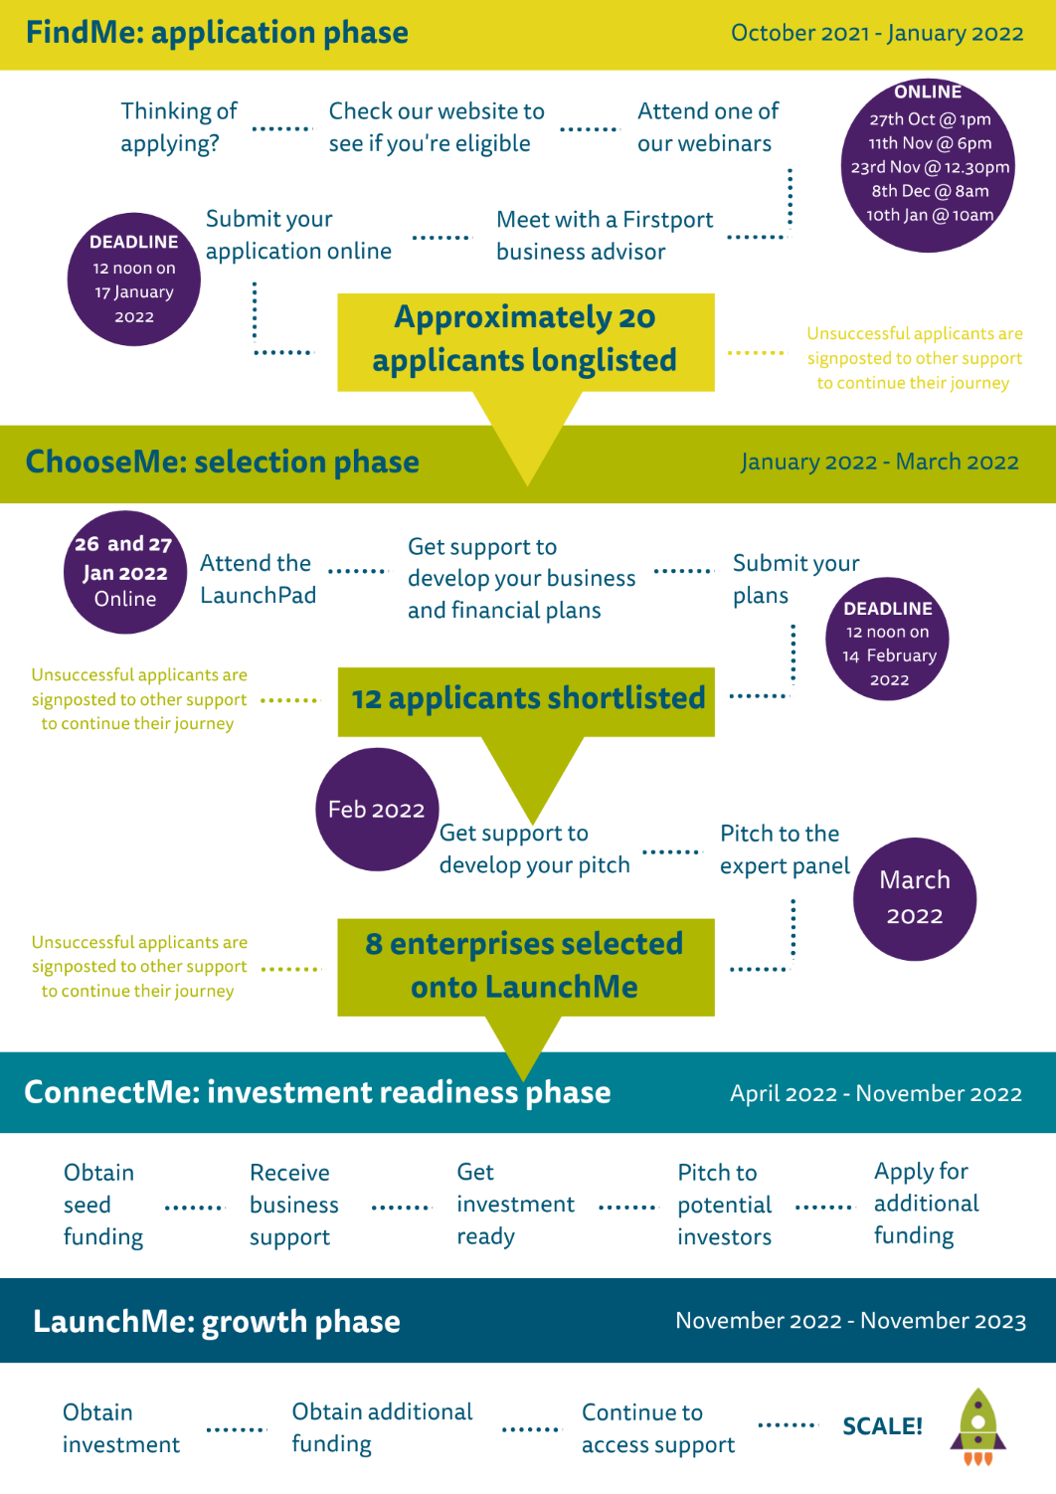

ChooseMe: LaunchPad

Following the online application process, you will be notified by Friday 21st January 2022 as to whether your application has been longlisted. Longlisted applicants will be selected based on those who are the closest fit to the LaunchMe priorities as indicated in these guidance notes. Individuals who are longlisted will be required to attend the LaunchPad event which is likely to be online on the mornings of 26th and 27th January 2022 (exact times tbc).

The LaunchPad event is designed to help applicants gain more information on the programme and help them to prepare for submitting their business plan and financial forecast as part of the next phase of the selection process.

It will provide you with an initial steer on the key features of a strong business plan and financial forecast, focussing on growth to secure investment. The event also provides the opportunity to network with other ambitious social entrepreneurs, find out more about what social investors are looking for and hear about the additional support and expertise available from our programme partners.

This is a key part of the selection process, so please ensure you are available to attend before submitting your application.

Following the LaunchPad, longlisted candidates will receive 1:1 guidance from an adviser to develop their business and financial plans. They will then submit revised plans by noon on the 14th February.

After the business plan submissions there will be a further shortlisting and up to 12 candidates will pitch to an expert panel. If you are successful in reaching this stage, you will receive 1:1 pitch support to ensure you are prepared for the expert panel which will take place at the end of March 2022. Up to eight social enterprises will be selected for the LaunchMe programme and proceed onto the ConnectMe phase.

ConnectMe: the journey to investment
The main purpose of LaunchMe is to give early-stage social enterprises and community organisations the support they need to become investment ready, preparing them to secure investment to realise their growth ambitions. The information below explains the journey to investment which takes place during the ConnectMe phase of the programme.

Step 1 - Seed funding
Throughout your application, you will explain how you would use the £10,000 repayable grant funding from LaunchMe in order to help your social enterprise become ‘investment ready’. This is called seed funding.

This funding must be spent during the ConnectMe phase (from April to November 2022), so please think carefully about what you need and how you will use it.

You should spend seed funding on getting ready to scale up – employing more staff, finding new premises, or purchasing more equipment. You may need specialist legal advice, or to develop your branding and marketing. These are just examples – if you are shortlisted for the programme, you will be given support to develop a detailed plan and budget for using your seed funding. Please note that seed funding cannot be used to pay off old debt.

Step 2 - Investment
If you are selected to join the LaunchMe programme, we will work with you to develop your business model and to strengthen your value proposition – what you are asking of investors. We will help you to meet and negotiate with potential investors to secure an investment deal.

Step 3 - Additional funding
We will also provide support to access a pool of grant funders who may act as co-investors to any private investment secured through the programme.

Please be aware that participants will be required to apply to grant funders through their usual application process – the additional grant funding is therefore not guaranteed and will be very competitive. However, your participation on the LaunchMe programme will strengthen your application and provide connections to a network of relevant funders.

We will also provide guidance on other means of securing funding. For example, crowdfunding, loan stock and community share offering.

Visit our website to read interviews of previous participants and find out more about their journey to secure investment and funding.

What is social investment?
Social investment refers to repayable finance that is intended to stimulate both financial and social returns. There are many different types of social investment. The simplest and probably most common model is when an investor gives a loan to a social enterprise. The social enterprise then uses it to generate social impact (for example, buying a new building to increase access for the people they want to help) and increase their turnover (for example, by having space for more customers). Unlike a grant funder, a social investor expects to be paid back some or all their investment, often with interest.

Social investment has been around for a while but for many organisations in Scotland, it might be new and this may be the first time they consider it. It is not without risks; you are after all taking on debt. However, it can provide growth opportunities for successful social enterprises, while building new relationships with investors who want to support the benefits that you deliver.

If you lead a social enterprise, are trading, and are thinking about growth, then social investment could help you. For example:

- You might need a capital injection to make a large purchase, for example, a building.
- You might need access to working capital or an overdraft facility to stabilise your cash flow through periods where lower sales are forecast.
- You might be looking for a bridging loan to help you take on new staff before they start to generate an increase in turnover.
- You know that there is potential to increase your customer base, but you need to invest in new equipment in order to deliver services on a bigger scale. You need some capital to get you going.

Social investors come in all shapes and sizes, and to date, LaunchMe participants have secured investment from a variety of sources, including:

à Individual investors. Most of the LaunchMe participants have secured their investment from individual investors. In many cases, we have helped participants to connect with suitable investors, although some participants found investors through their own networks and contacts. In most instances, when you work with an individual investor, you can negotiate competitive interest rates and repayment plans. You can also get the added value of accessing your investor’s knowledge, expertise and contacts.

à Social investment providers. These may be Community Development Finance Institutions (CDFI) or ethical banks that offer specific products for charities and social enterprises. Some LaunchMe participants have secured part of their investment this way, primarily from Social Investment Scotland.

à Your own community. You may decide to raise some of your investment through crowdfunding or a loan stock option, by attracting individuals and organisations who share a common interest with you and what you are trying to achieve. Individuals who invest in you through a loan stock option do not ‘own’ any of your business. This is a debt investment so they would be lending you money which you would be due to pay back with interest.

Which source of investment is best for you will depend on your growth plan and it may involve a combination of any of the above. We will help you throughout your involvement in the programme to understand and access the best option for you.

What is social investment tax relief?
Social investment tax relief (SITR) helps social enterprises raise finance by offering tax relief to individual investors.

SITR is designed to help you raise money to support the trading activity of your social enterprise or charity. It does this by offering your investors tax relief on their investment if the qualifying conditions are met.

Whilst compliance with SITR is not a requirement to participate on LaunchMe, it is an attractive proposition for potential investors and as such we would encourage applicants to look at the SITR rules.

Read the full details on SITR from the HMRC here. If you have any questions, please email us on launchme@firstport.org.uk.

A note on State Aid
State Aid is a specific legal term arising from the European Union treaty which constitutes financial aid to organisations carrying out economic activity (whether or not for profit) which could distort competition. We need applicants to consider whether their project meets State Aid requirements.

If LaunchMe funding could give you an advantage over other organisations offering similar goods or services, or if the activities you want us to fund could affect trade between EU member states, then our funding might be considered to be ‘State Aid’. You can find out more about State Aid here.

State aid rules are complex, but as a very general guide projects involving trading activities are unlikely to breach state aid rules if they are small scale; delivered in a defined local area; are for charitable, social, cultural or educational purposes; and do not affect trade between member states of the European Union.

It is your responsibility to understand your State Aid position when submitting an application to us for funding and when signing any subsequent contract.

If you’re not sure whether you meet these criteria, please get in touch before you submit your application.

Completing the application form
Applications must be made online by completing the online application form.

If you need an application form or this document in another format, please contact us on 0131 564 0331 or email launchme@firstport.org.uk.

The form is designed to give us a brief overview of your social enterprise, so you shouldn’t need to write more than the word limits.
The online form does not allow you to save your progress as you go through. Therefore, it is highly recommended to draft your answers using our Word Document Application Draft, prior to starting the online form.

You must submit your completed application form by 12 noon on Monday 17th January 2022.

If you have any queries or would like support to strengthen your application, we would encourage you to engage with our team at one of our webinar events (see page 1 for dates and times) or e-mail launchme@firstport.org.uk to arrange a phone or zoom call.

The application form has some detailed questions that require you to elaborate on your social enterprise. The information below provides some detail to guide you as to what you might include.

- Your Pitch
Tell us what you do in no more than 3 sentences - what is your product or service, who is it for, and what benefits does it create?

- Explain how you feel that you meet the LaunchMe priorities (250 words)
These guidance notes outline the type of organisation that we aim to support. You should explain how you meet these priority areas, are best placed to make use of the LaunchMe programme and how your organisation would benefit.
- Commercial operation including track record (250 words)
Tell us more about the commercial part of your business model. What is your vision and ambition for your business? Who are your customers for each of your products or services, how do you reach them and how big is your market? How much do you charge for your products or services? Who are your competitors and what sets you apart from them? Is there room to reach more or different customers? What is your commercial track record to date (sales, turnover, sales pipelines)?

- Social Impact including track record (250 words)
How does your business create social impact? How did you identify this social challenge and is there evidence of need? How do you interact with your beneficiaries? How do you measure the effectiveness of your solution – how will you know that positive change has taken place? Demonstrate the impact that you have had to date.

- Your people, networks and partnerships (200 words)
Tell us about the people who set up and run your business. What are your motivations, and what experience do you, your staff and board members bring of running a business and/or creating social impact? Who are your key partners and how do they add value to your own experience? What networks are you involved in and how do these help you to access your market? How is your business managed (e.g. role of the Board, staff structure)?

- Growth plan & capital required (250 words)
Tell us what your growth plans are for the next 3 years. What are your targets for financial growth and social impact? What do you need in order to scale up (people, property, equipment)? How will you manage growth – how will your staffing or structure change to meet increased turnover? How do you know that this is the right time for your business to scale up (market opportunities, your experience)? What are the main risks to achieving your growth plans, and how will you mitigate them? What will you spend the £10,000 seed funding on in the next 12 months? How much investment do you require to meet your growth plans, what will it be spent on and what will the impact be on the business?

The application process
We would encourage you to submit your application at any time before the deadline. After submitting your application online, you will receive an automated reply acknowledging receipt of your submission. If you have any questions about the application process, please contact us by e-mailing launchme@firstport.org.uk.

You will be advised of the outcome of your application within one week of the deadline date. Ineligible applications will be notified by e-mail within two weeks of submission. Longlisted applicants will be contacted by email and will be required to attend the LaunchPad event on 26th and 27th January 2022. See page 2 for further details on the LaunchMe journey.

I don’t think my social enterprise is ready to apply for LaunchMe
Firstport provides free training on all aspects of setting up and running a business through the Just Enterprise programme. Find out more and register on the Just Enterprise website.

Firstport also offers funding to support start-up social enterprise. You can apply for up to £5,000 to get your idea off the ground, or up to £25,000 if your business is able to show evidence of a track record in generating income and social impact. You may also be eligible for our repayable grant: Boost It. Boost It offers up to £50,000 in repayable grants to help social enterprises in need of a large capital injection to get their ideas up and running, or to sustain trading. Find out more about our other funds online.

