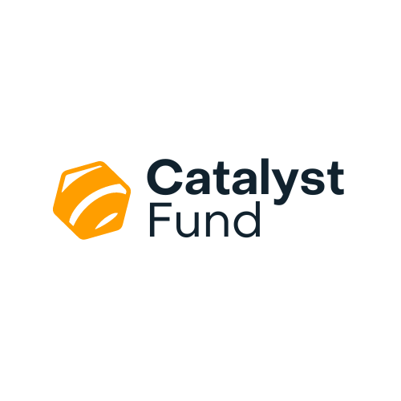

**Investment proposal form**

**Instructions:**

To apply to the Catalyst Fund, you need to fill in an online application form at [https://community.firstport.org.uk](https://community.firstport.org.uk.)

You will be asked to upload this document when you reach the ‘Supporting Documents’ section. The following questions are designed to help us understand more about your business and growth plans. You should answer accurately and thoroughly.

If you are having issues with the accessibility of the form, let us know by emailing [info@firstport.org.uk](mailto:info@firstport.org.uk).

|  |
| --- |
| Answer each question in the white section underneath the relevant question. The text box will expand as you write. There are no word counts in this document. This is to make it easier for you to complete it in a way that makes sense for your ambitions. We also strongly encourage you to collaborate with your investment readiness support provider in preparing answers to these questions. |
| 1. Is the investment you are applying for to the Catalyst Fund part of a larger funding package required?   If so, please detail other funding secured/applied for. |
|  |
| 1. What will this investment be used for? |
|  |
| 1. What are the main drivers of revenue and costs in your business model?   This is not just listing the assumptions in the cashflow but describing the forces make them increase or decrease. (eg volume, customer loyalty, seasonality, inflation, market growth). |
|  |
| 1. How will you reach your potential customers?   (eg paid advertising, networks, word of mouth) |
|  |
| 1. What evidence do you have that customers will buy your product or service?   (e.g. market research, trial sales, letter of intent) |
|  |
| 1. Describe your key strengths that will help you achieve your goals.   (e.g. innovation, team, location, partnerships) |
|  |
| 1. What do you believe are the key risks that may prevent your organisation from achieving its goals? How are you addressing these risks?   (e.g. unexpected competition, skill gaps, economic uncertainty, failed partnerships, team burnout, regulatory environment) |
|  |
| 1. How will you have an impact on a social and/or environmental problem? How do you know your solution will contribute to solving the problem? |
|  |
| 1. How will you measure and report on your impact? |
|  |
| 1. What financial management processes and financial controls do you have in place?   (e.g. budgeting, cashflow analysis, bank reconciliations, segregation of duties) |
|  |
| 1. As part of this application, you will provide 3 years’ detailed financial forecasts. How do you think the business will develop beyond this point? Will revenue continue to grow or will it level off at some point? Will you require further investment to grow? |
|  |